|  |
| --- |
| GAME NAME: Crown and Anchor Game |
| EXAMINER: Hung Ngoc NGUYEN |
| DATE: 20/10/2017 |

Tracing bug 1- Incorrect Payout

1. Incorrect results

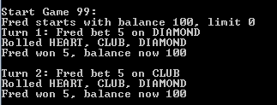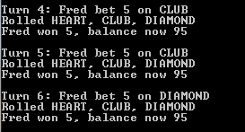

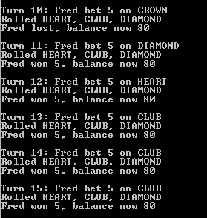

1. Initial bug, /4-Resolution (source)/Game.java, line 42

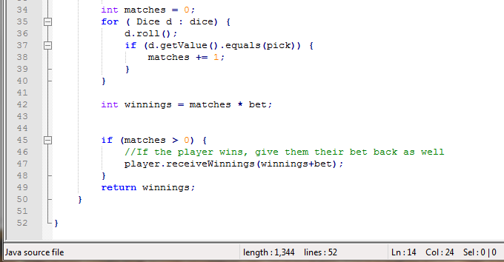

1. Resolved bug, /4-Resolution (source)/Game.java, line 42



1. Correct result:

